SPRING REST HANDSON
MANDATORY
HANDS ON 1: CREATE A SPRING WEB PROJECT USING MAVEN
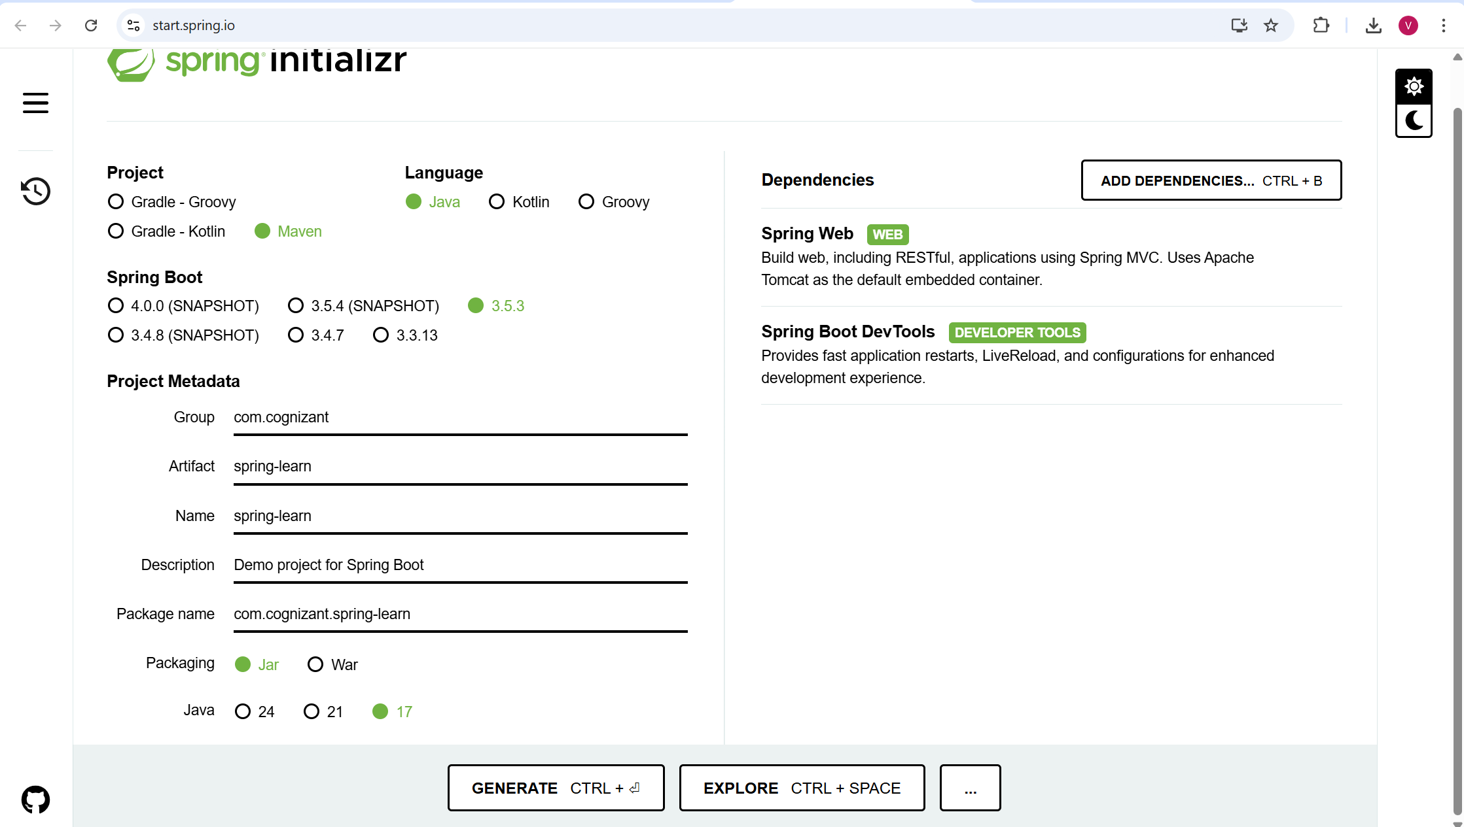

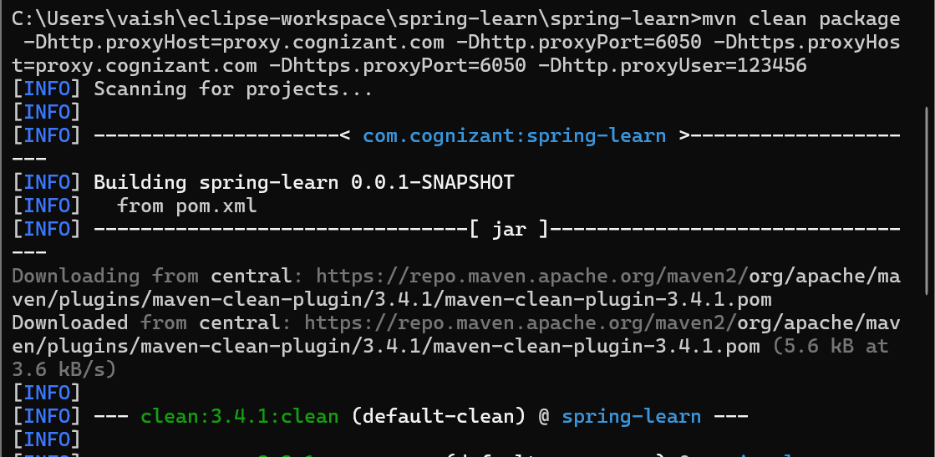
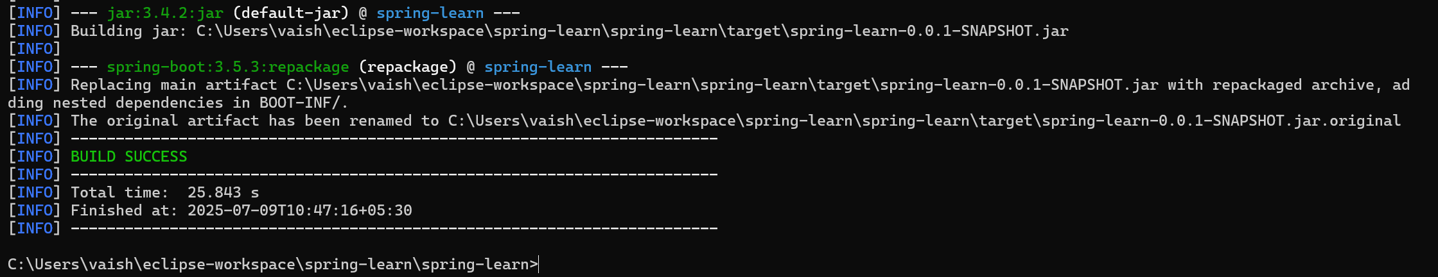

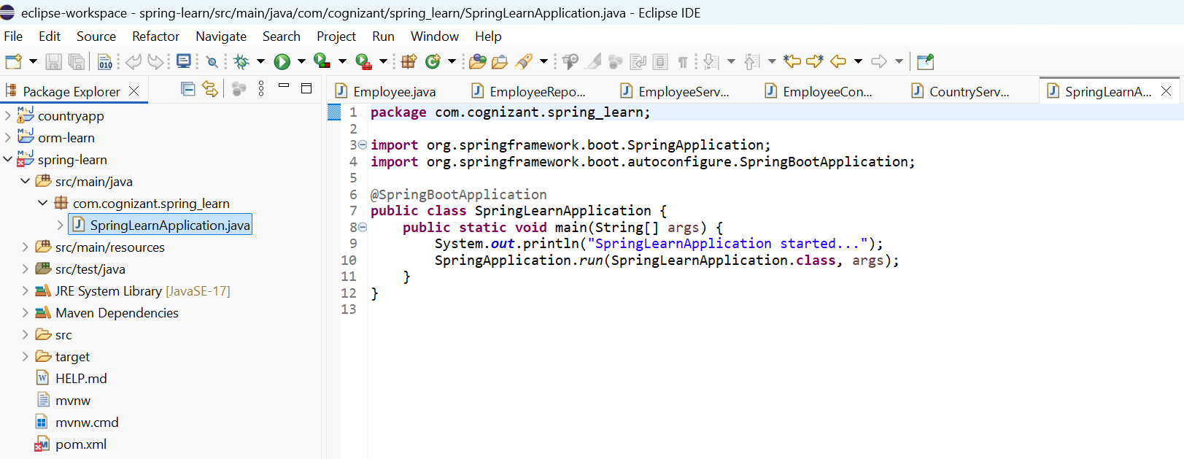

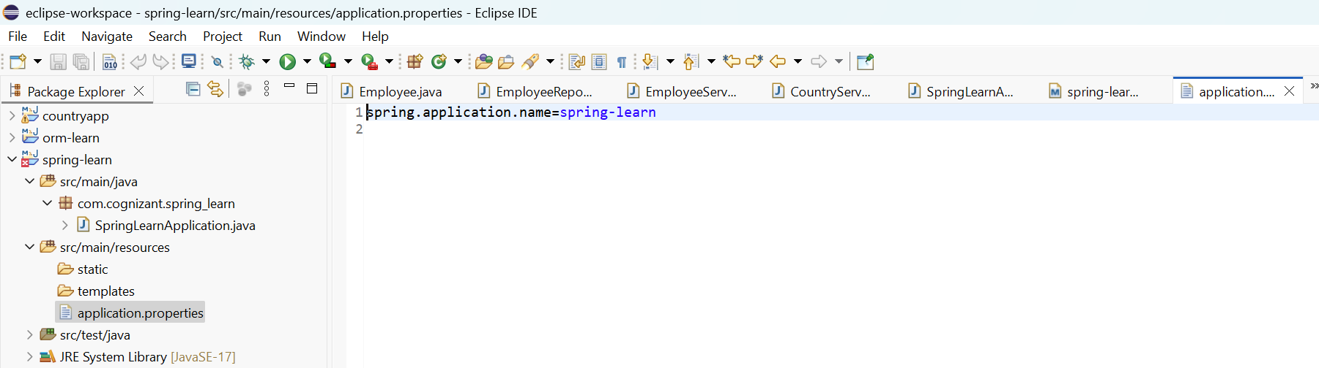

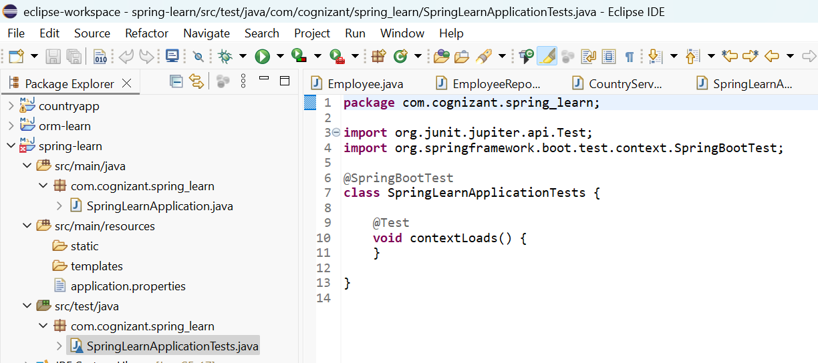
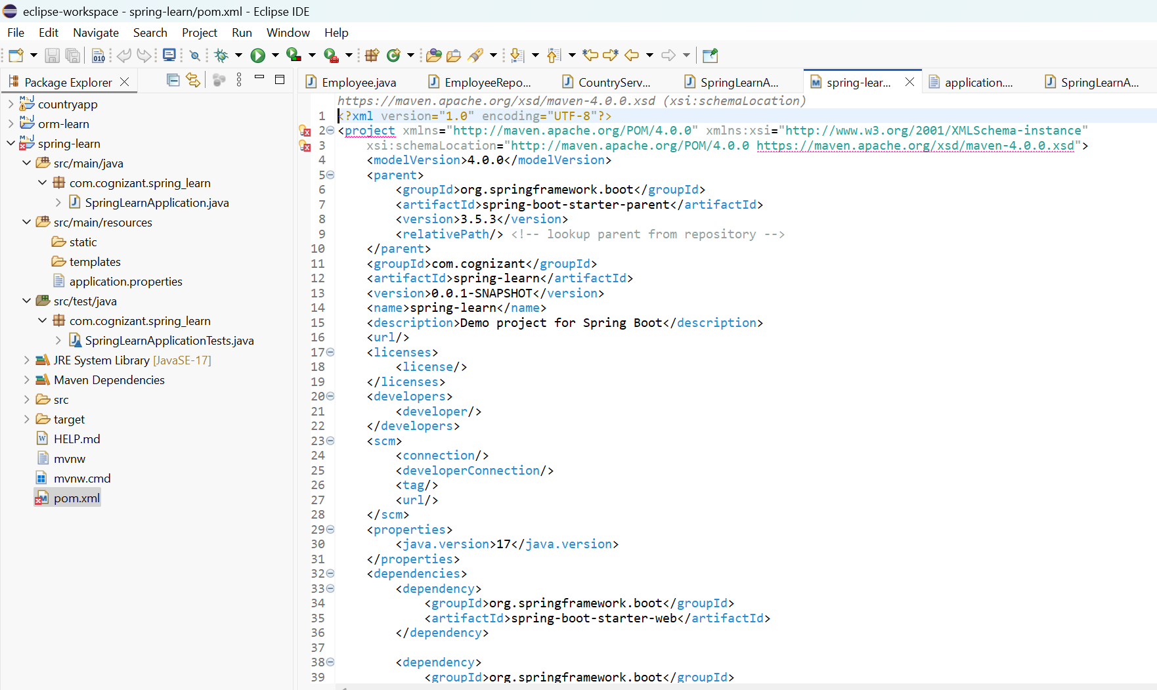

OUTPUT:
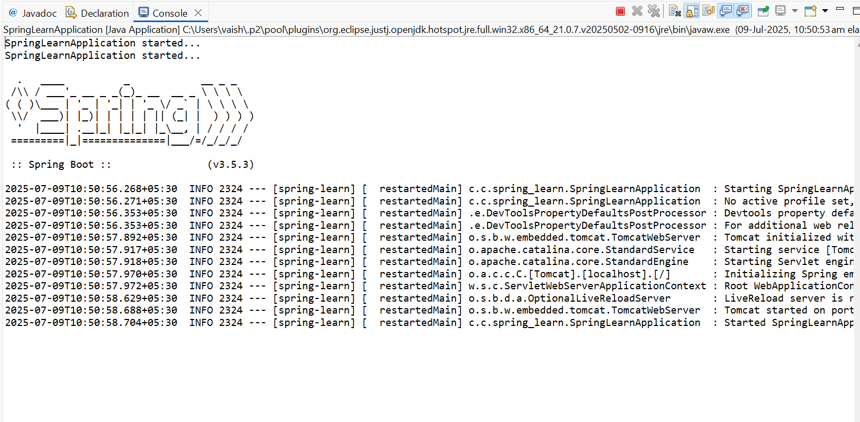

HANDS ON 2: SPRING CORE – LOAD COUNTRY FROM SPRING CONFIGURATION XML
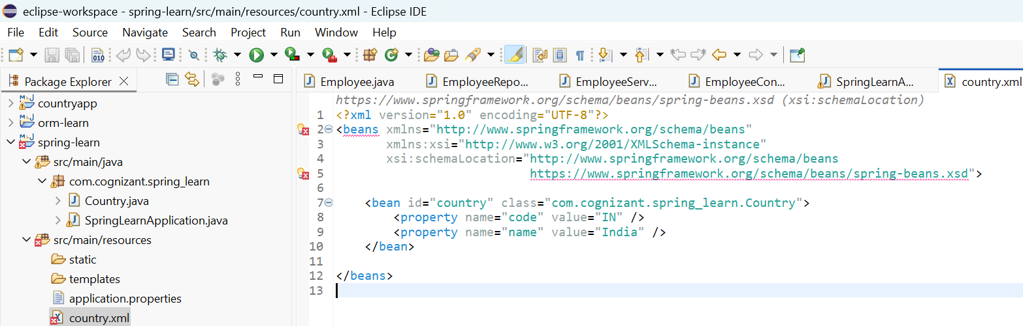
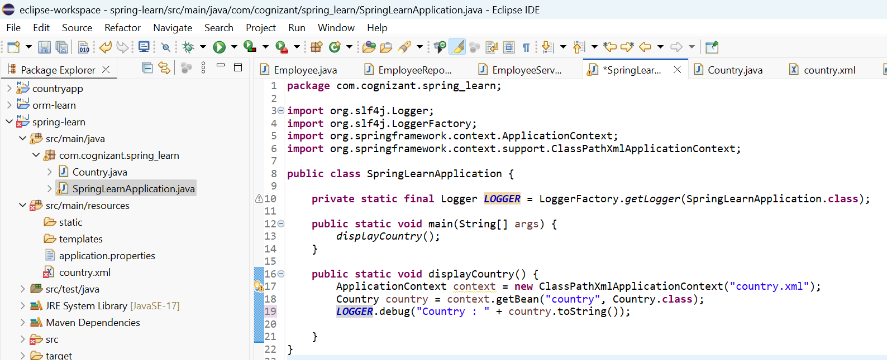

OUTPUT:

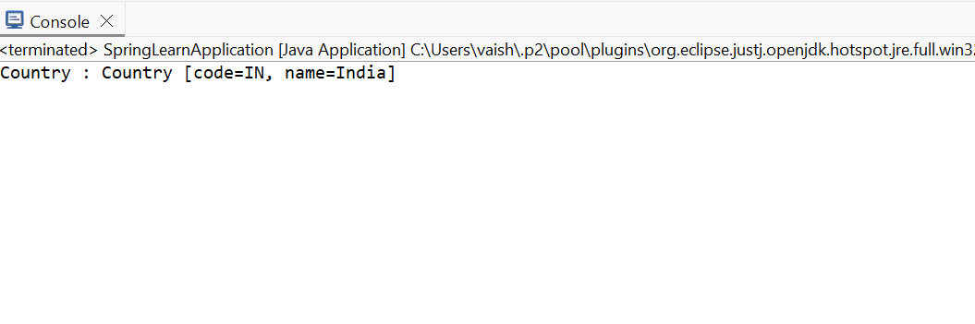

HANDS ON 3: HELLO WORLD RESTFUL WEB SERVICE
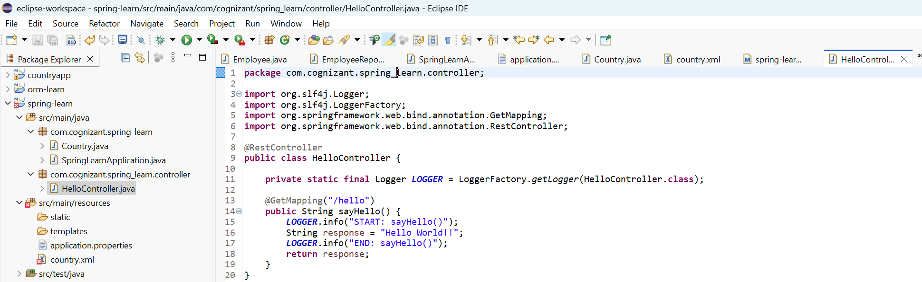

OUTPUT:
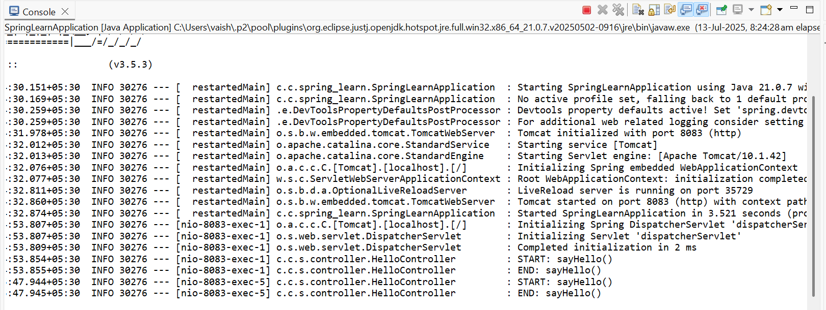
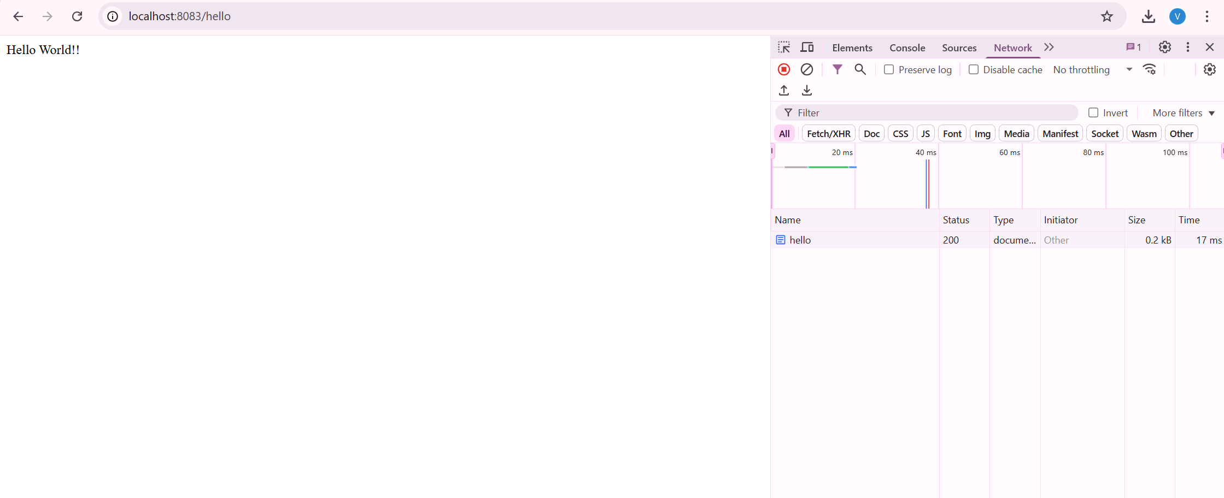

HANDS ON 4: REST - COUNTRY WEB SERVICE
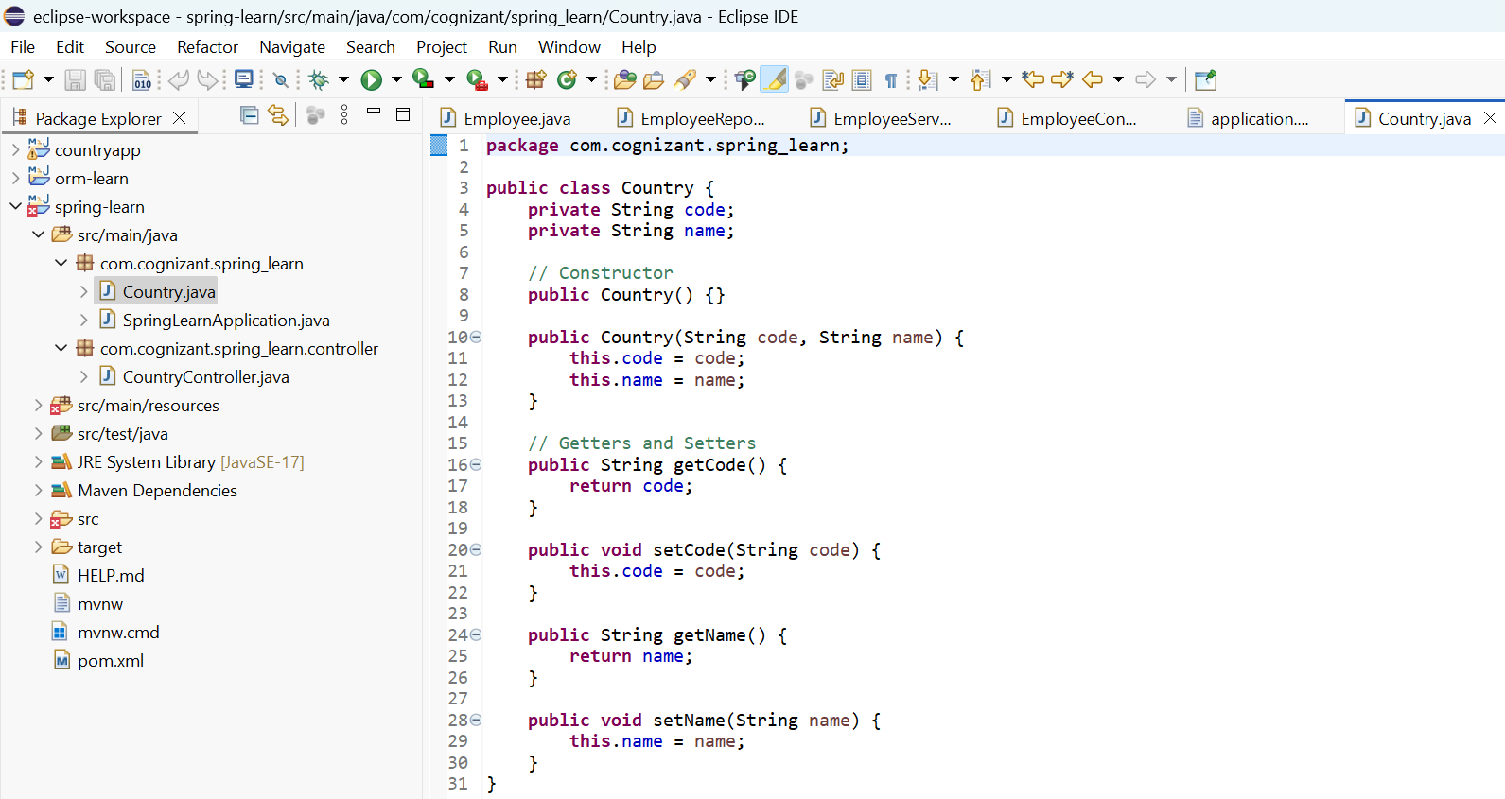
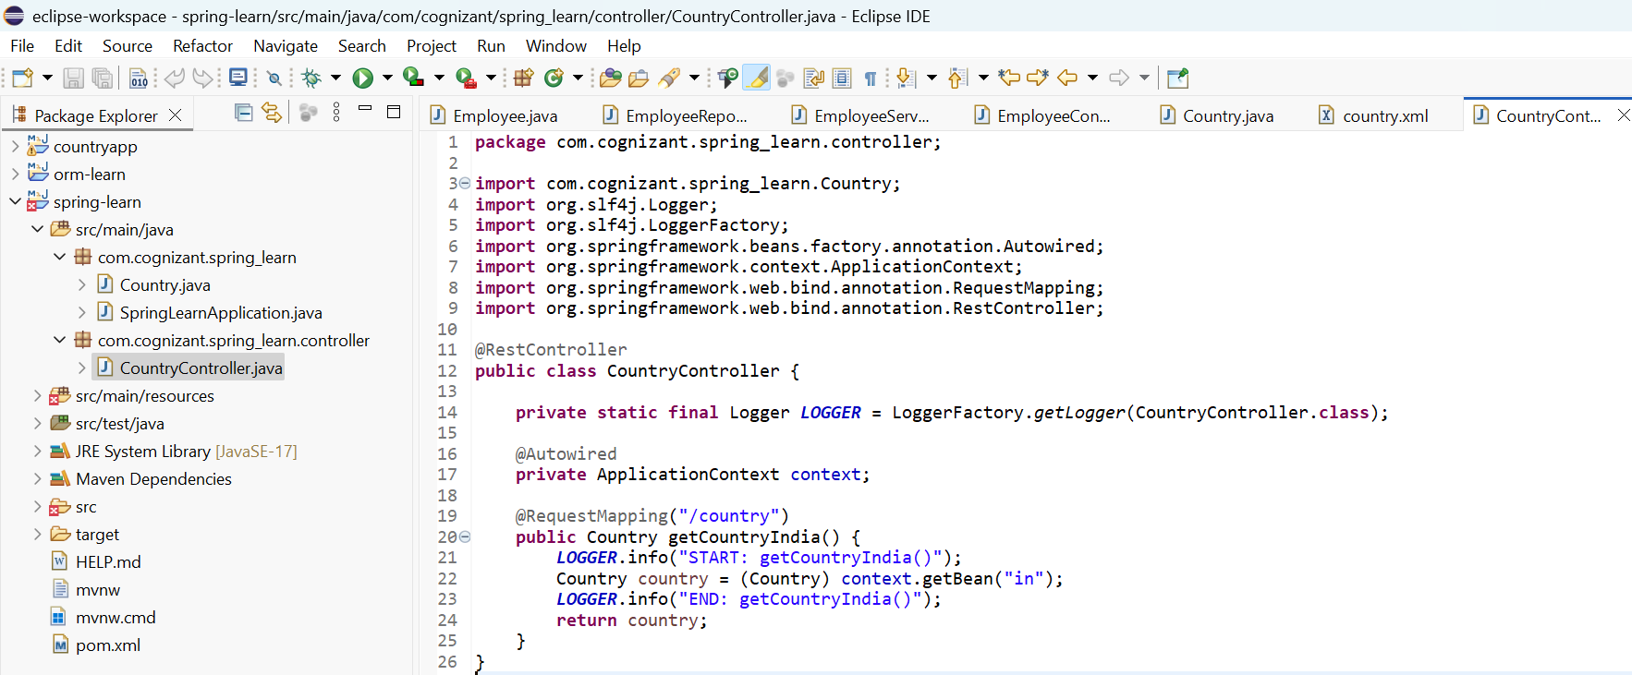
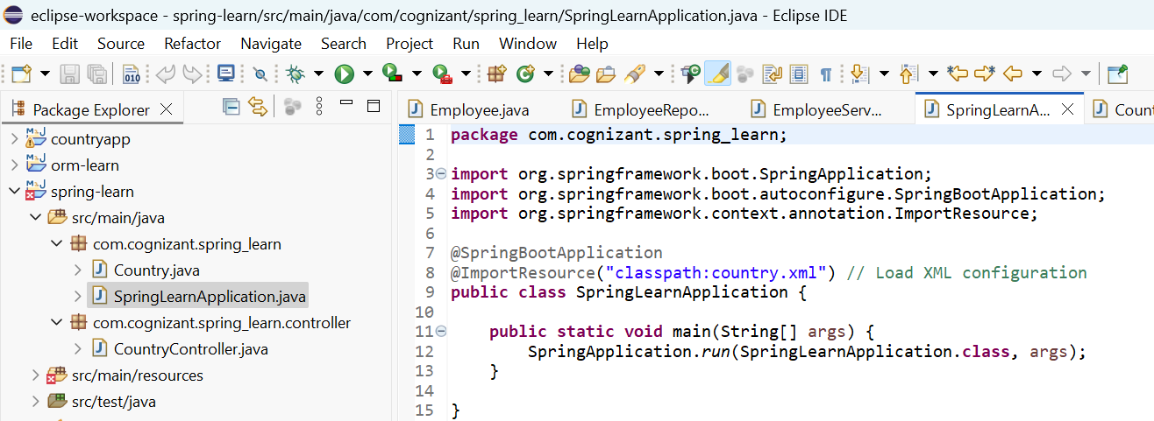
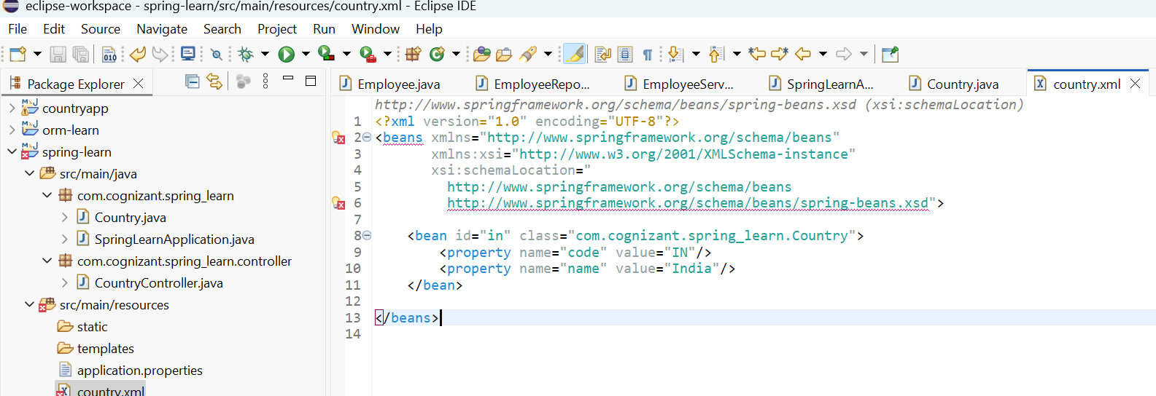

OUTPUT:
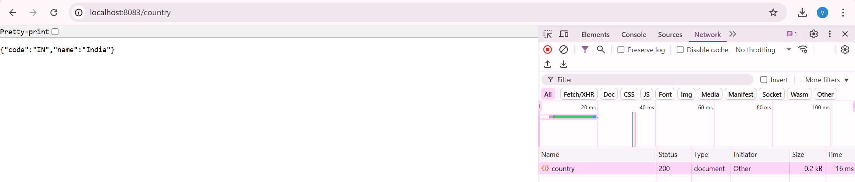

HANDS ON 5: REST - GET COUNTRY BASED ON COUNTRY CODE
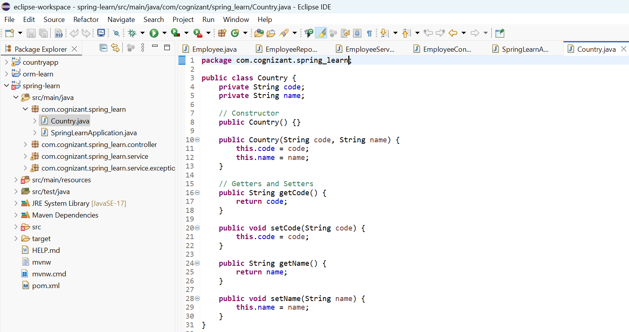

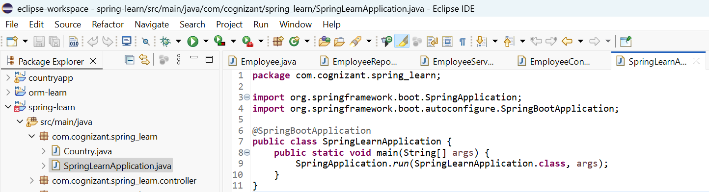

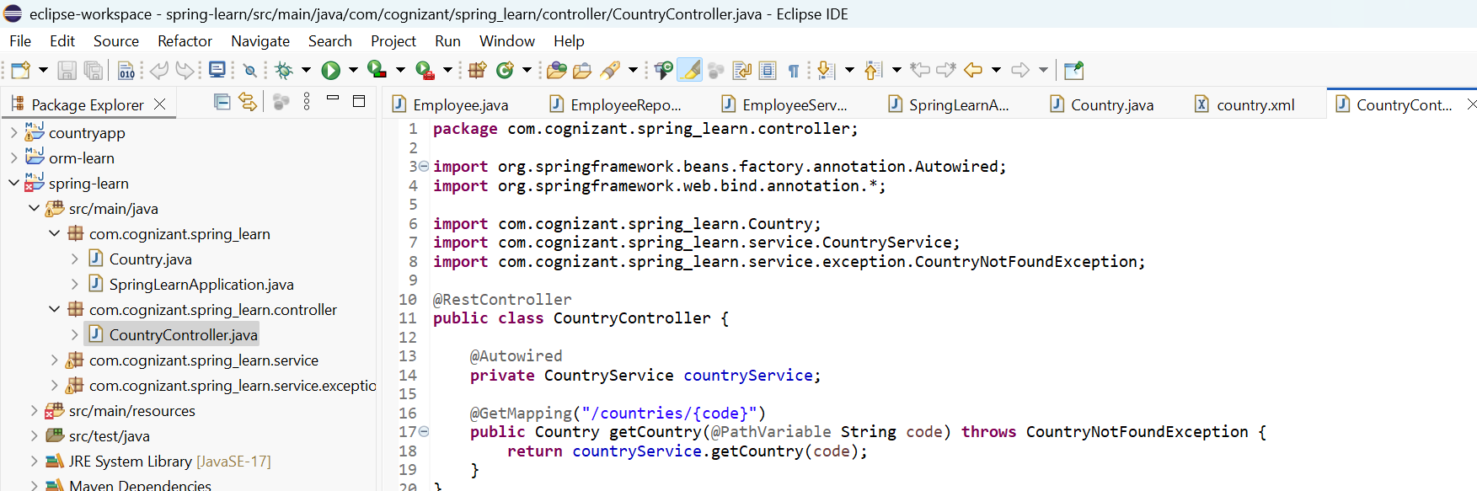

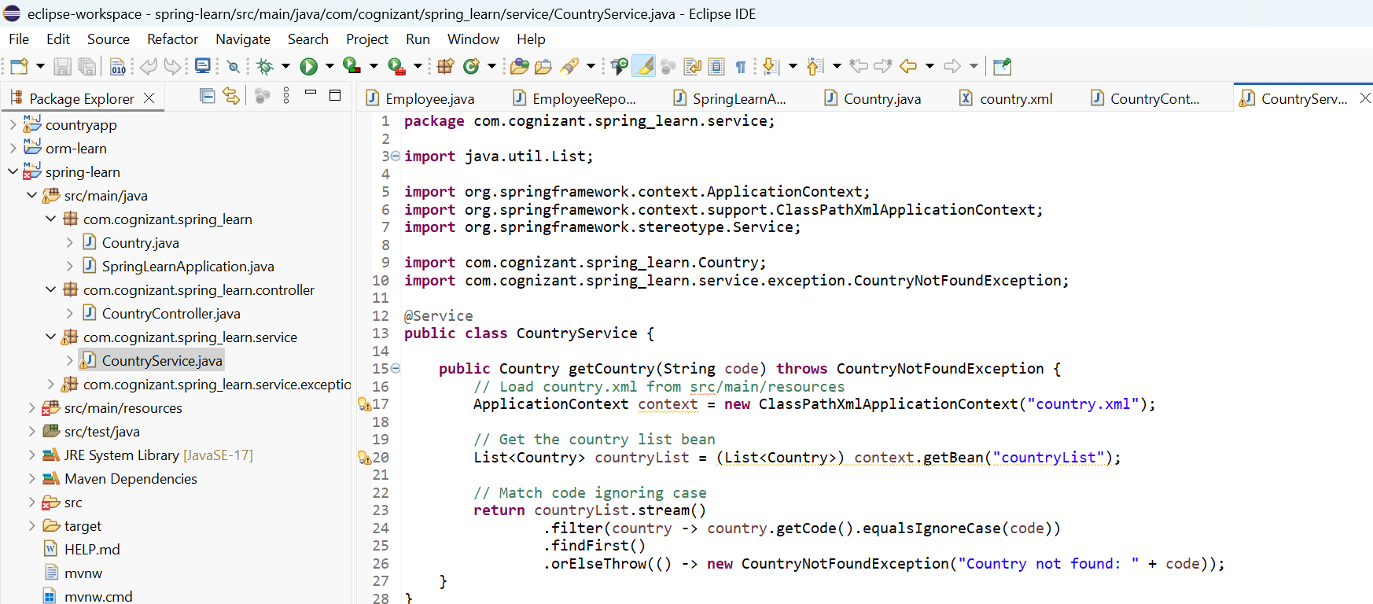
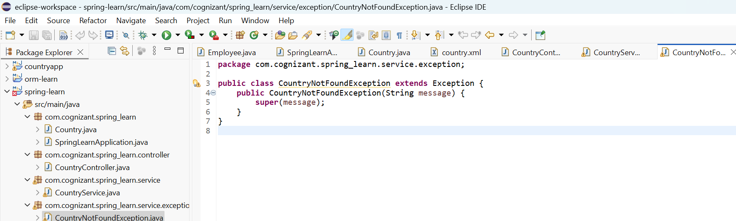

OUTPUT:
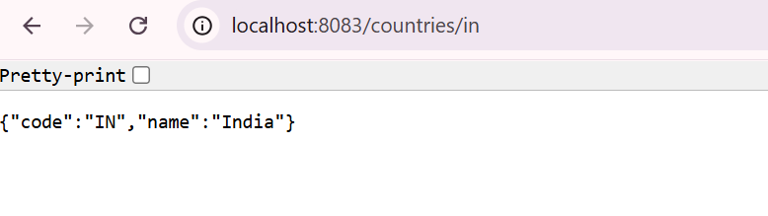

HANDS ON 6: CREATE AUTHENTICATION SERVICE THAT RETURNS JWT

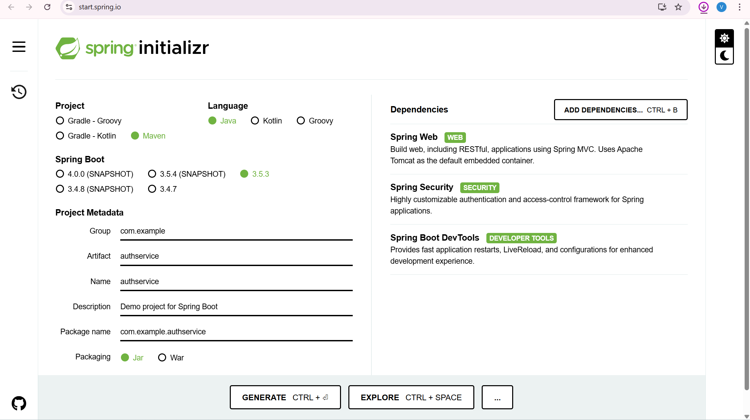

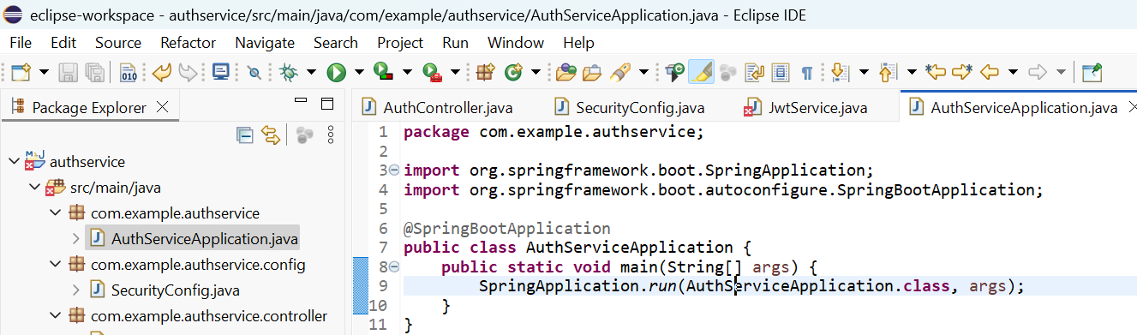
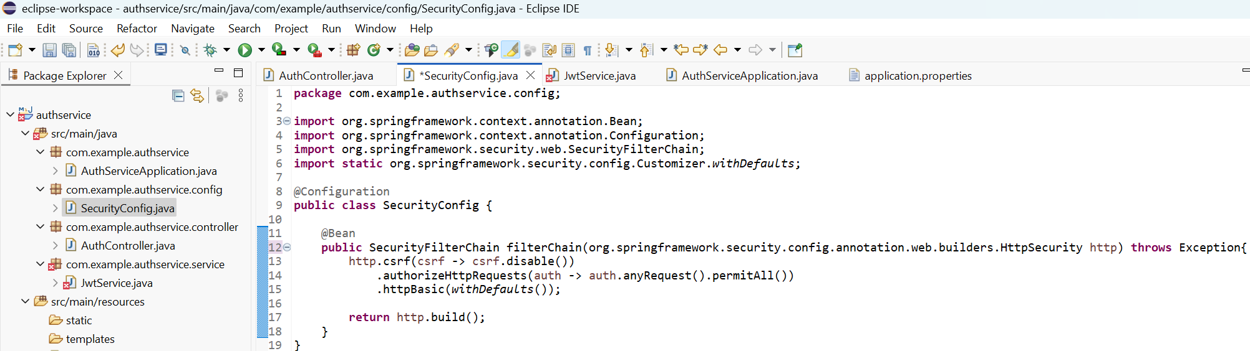
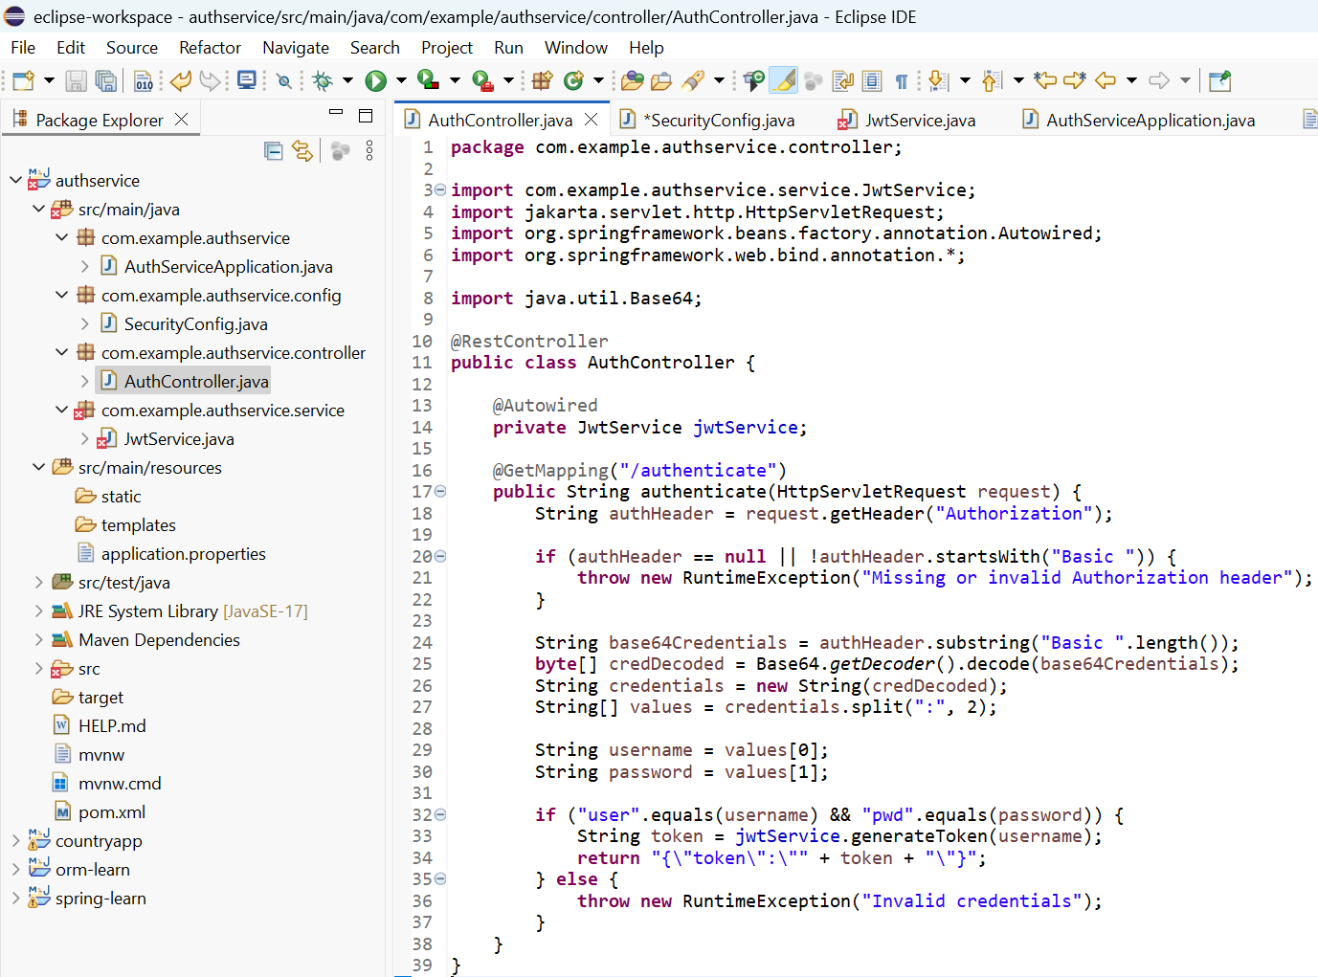

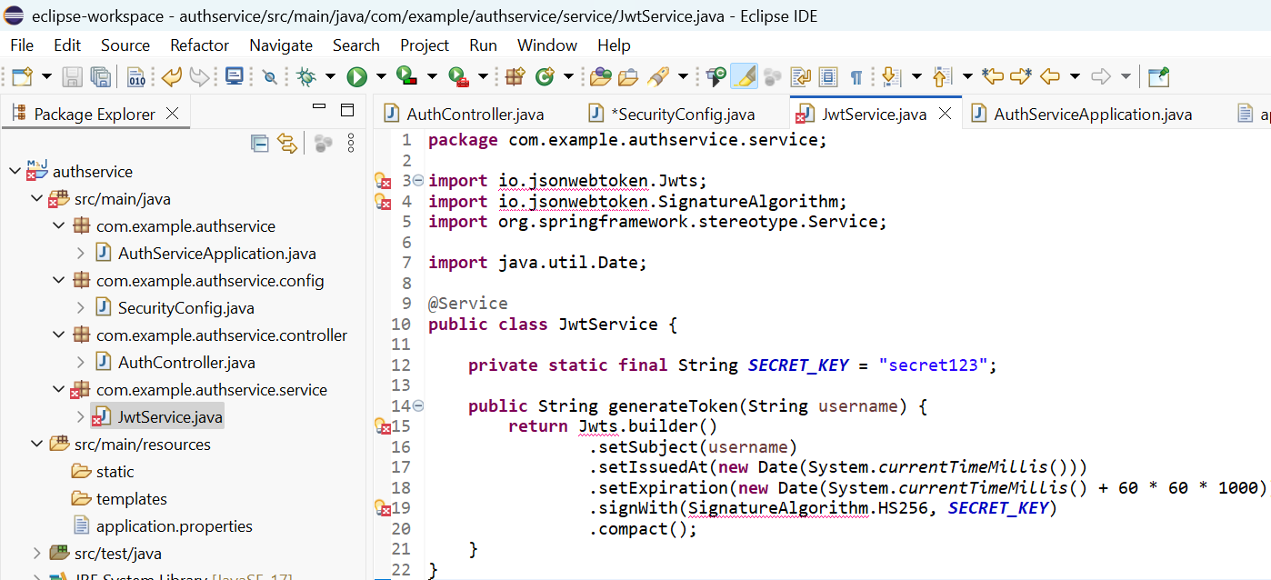
OUTPUT:
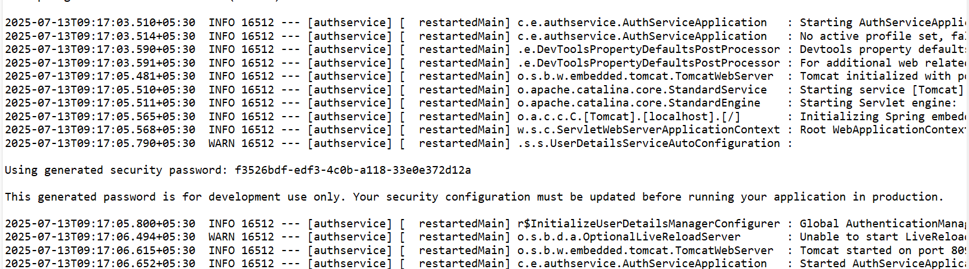
ADDITIONAL HANDS ON
DISPLAY EMPLOYEE LIST AND EDIT EMPLOYEE FORM USING RESTFUL WEB SERVICE

